ANTS for the Human Exploration and
Development of Space

Dr. Steven A. Curtis
Code 695, Planetary Magnetospheres Branch
Laboratory for Extraterrestrial Physics
NASA Goddard Space Flight Center
Greenbelt, MD 20771
Phone: 301-286-9188;
Email: Steven.A.Curtis.1@gsfc.nasa.gov

Walt Truszkowski
Code 588, Advanced Architectures and Automation
NASA Goddard Space Flight Center
Greenbelt, MD 20771
Phone: 301-286-8821;
Email: Walter.F.Truszkowski@gsfc.nasa.gov

Dr. Michael L. Rilee
L-3 Communications, EER
Mailstop 931, NASA Goddard Space Flight Center
Greenbelt, MD 20771
Phone: 301-286-4743;
Email: Michael.L.Rilee.1@gsfc.nasa.gov

Dr. Pamela E. Clark
L-3 Communications, EER
Mailstop 931, NASA Goddard Space Flight Center
Greenbelt, MD 20771
Phone: 301-286-7457;
Email: Pamela.Clark@gsfc.nasa.gov

Abstract- The proposed Autonomous Nano-Technology Swarm (ANTS) is an enabling architecture for human/robotic missions envisaged by NASA’s mission for the Human Exploration and Development of Space (HEDS). ANTS design principles draw on successes observed in the realm of social insect colonies, which include task specialization and sociality. ANTS spacecraft act as independent, autonomous agents for specific functions, while cooperating to achieve mission goals.

For example, the Prospecting ANTS Mission (PAM) is a long-term mission concept for the 2020-2025 time frame involving individual spacecraft agents that are optimized for specific asteroid prospecting functions. The objective of PAM is to characterize at least one thousand asteroids during each year of operations in the Main Belt. To achieve this objective, PAM spacecraft, individually and as a group, must achieve a high level of autonomy.

This high degree of autonomy opens the possibility of a new kind of interaction between humans and these spacecraft, where human explorers and developers could interact with ANTS enabled resources by communicating high-level goals and data products. Thus ANTS enables new kinds of missions in which both human and robotic agents work together to achieve mission goals.

In this paper we review and discuss the ANTS Architecture in the context of the HEDS mission.
Table of Contents
- Introduction
- The ANTS Architecture
- The HEDS Strategic Plan
- The Role of ANTS and HEDS
- Conclusion

- Introduction
The mission of NASA's Office of Human Exploration and Development of Space (HEDS) is to expand the frontiers of space and knowledge by exploring, using, and enabling the development of space [1]. The aim is to discover and develop the resources of Space, transforming them into economic factors for the benefit of human enterprise. To this end, HEDS has established five goals for its Strategic Plan.
- Explore the Space Frontier
- Expand Scientific Knowledge
- Enable Humans to Live & Work Permanently in Space
- Enable the Commercial Development of Space
- Share the Experience and Benefits of Discovery
The path into the future towards these goals goes through four epochs of steadily increasing potential and steadily increasing challenges. The range of these epochs is roughly as follows.
- Near-term: within 6 years, mission durations of weeks and months
- Mid-term: within ten years, six month-long missions
- Far-term: beyond ten years, 1 to 3 year missions (essentially permanent presence in space)
- Beyond: permanent human activity in space

The Near-term corresponds to mission concepts, technologies, and science that are either operational or are soon to be implemented. These are built using technology for which flight heritage has already been demonstrated. Human space flight mainly involves the International Space Station or the Space Shuttle. The human presence in space is the main span of the bridge through the Mid- and Far-terms, but this span is supported and held together by an infrastructure of outposts, transportation and communication systems, many of which are robotic. Indeed, HEDS sees the distinction between human and robotic missions eventually vanishing, with missions in the Mid-term starting to feature a high degree of integration of human and robotic systems.

Mission and System Architectures
A mission in which human and robotic elements are highly integrated, cooperative, and interactive cannot be handled with the current, traditional paradigm for spacecraft operations. Currently, most spacecraft are, in the main, open-loop commanded by an Earth-based ground operations team with important, but limited, exceptions for certain health-and-safety related functions. The generation, review, transmission, and diagnosis of results of command sequences are all part of an intricate and resource-demanding process that occasionally produces catastrophic results. Without advances in automation, the traditional spacecraft operations staff cannot simply be transferred from the Earth to manned-spacecraft comprising the human-element of advanced HEDS missions. Multiple-element missions must be no more difficult or demanding to operate than individual spacecraft missions are today: the demands of controlling the robotic element must not be so great as to overwhelm the human resources of the well-integrated mission.

ANTS Background
The Autonomous Nano-Technology Swarm (ANTS) is a mission/systems architecture for scalable, robust, highly distributed systems [2]. There are three key aspects of the architecture.

- Independent, specialized elements
- Multi-level intelligent, autonomous behavior
- Organization via a Social Insect Analog

The aggressive use of nano-technology brings the benefits of miniaturization to spacecraft systems, which include mass producibility and multi-function devices (e.g. system-on-a-chip). However, the foundation of the ANTS concept is specialization, whereby individual elements of the system are optimized for particular mission functions. This improves the use of limited mission resources, but requires cooperation among different members of a swarm to achieve mission goals. Because space is a harsh environment in which systems suffer faults and failures, individual members of the swarm must be robust and intelligent enough to maintain their mission functions and roles in spite of such difficulties. Coupling intelligent behaviors as closely as possible to the systems that suffer the immediate consequences of those behaviors simplifies the control of those systems. Individuals can interact at a higher semantic level across lower capacity, relatively unreliable communication links, confident that fundamental tasks are autonomically provided and that details are understood to be grounded in the mission context. From these specialized factors, important mission functions are provided and the foundation for collective behaviors is laid. Utilizing these principles, colonies of social insects have become some of the most successful and adaptive creatures on the planet [3].

Plan of paper
Clearly the technologies required by HEDS goals are quite advanced. Second, ANTS is a challenging paradigm that requires much research and development to reach its potential. The HEDS Strategic Plan surveys the path towards its goals and identifies capabilities that need to be developed: in this paper we show that the ANTS Architecture is relevant at every step along the strategic path leading to HEDS goals. In the following we present the ANTS Architecture in more detail. We then discuss the relevance of ANTS to HEDS objectives.

- The ANTS Architecture
As mentioned above, the ANTS Architecture is motivated by the success of social insects, in particular ants, over the past 60 million years. The basis of this success mainly lies in the specialization and division of labor of the members of an insect colony. The tasks that insects must perform in order to live and propagate are the familiar ones of gathering and preparing food, obtaining a suitable living environment (e.g. shelter, foraging area), finding and securing mates, and preparing the next generation. If not members of a social group, insects must be able to manage by themselves, i.e. as individual generalists. In general, such insects cannot evolve exceptional capabilities to the great detriment of one or more of the myriad life-critical functions. A great strength may not offset even a marginal weakness.

However, in the context of colonies of social insects, specialists can evolve that are much more able to perform some of the tasks that support life. As long as the activity of the different kinds of specialists covers the needs of the colony members, the group can perform the myriad of tasks more efficiently and successfully than a similar number of individual generalists.

So within this discussion, current mission design and spacecraft architectures are best classified as generalists, at least for science missions. This generalization is not exemplified in the functions common to all spacecraft: command and control, attitude, mechanical structures, power generation, and so on. Instead, the generalization is apparent in how the mission payload is considered and how this drives the overall design of the mission and spacecraft.
Figure 1. Optimal position for X-Ray Spectrometer (XRS) compared with actual NEAR geometry.
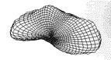
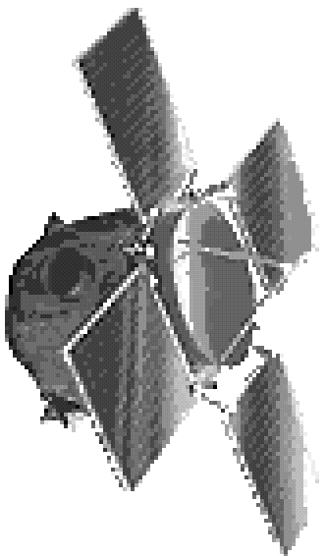
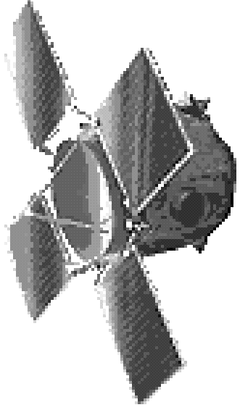
The generalization arises because current science mission and spacecraft architectures carry several science instruments. Even for the relatively favorable case where the instruments are focussed on related science goals, the operational characteristics of the instruments may lead to unavoidable conflicts. In addition to conflicts with other science instruments, it is common for the needs of the science instrumentation to be somewhat at odds with the more mundane health and safety concerns related to the very functioning and survival of the spacecraft.
Towards the Sun
Asteroid (EROS)
XRS
OPTIMAL
POSITION
SUB-OPTIMAL
COMPROMISE

Consider the Near Earth Asteroid Rendezvous Mission: optimal orbits for its X-ray spectrometers pass through the line between the asteroid and the Sun (Figure 1) [4]. Such orbits provide opportunities to obtain the greatest signal-to-noise ratio in these instruments. However, due to power concerns, communications, and related pointing constraints, NEAR rarely passed through this point, spending most of its time orbiting the asteroid over its terminator, essentially at a right angle to optimal positioning for the spectrometers. Thus the NEAR orbit was a compromise arrived at by trying to accommodate within the mission's budget the conflicts and limitations of various spacecraft subsystems.

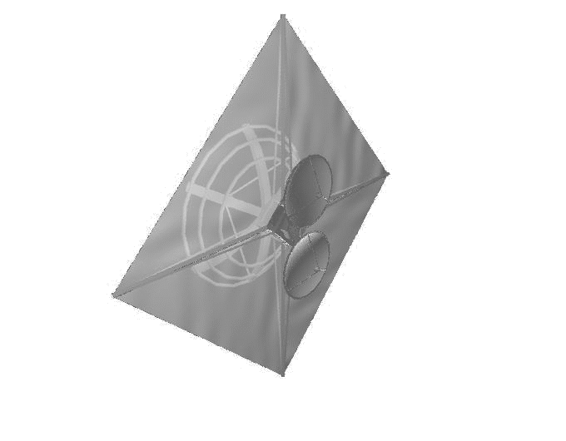
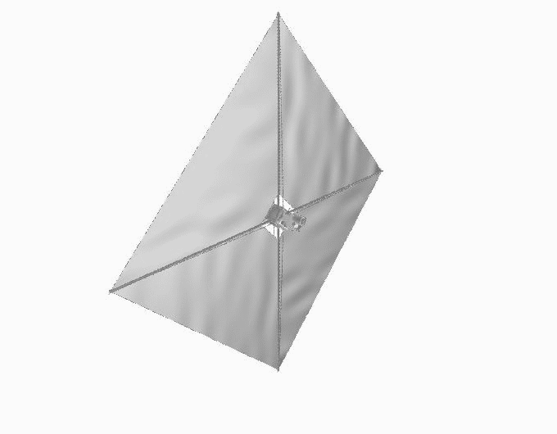
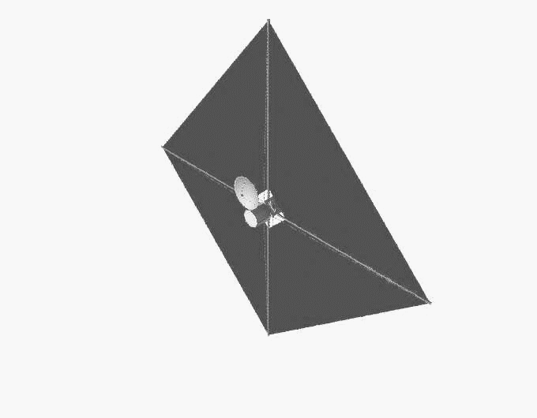
The ANTS Architecture is especially relevant when mission functions might advantageously be employed simultaneously at different positions (Figure 2). For the current, single spacecraft, multi-instrument approach, the advantage of multiple positions may be lost in face of the expense of implementing multiple traditional spacecraft. Command, control, and autonomous operations are hampered by the complexities of the payload operations compounded by the need to coordinate multi-spacecraft observations to achieve mission goals. Yet to be viable mission candidates in the future, multi-spacecraft missions must be no more expensive or difficult to operate than single-spacecraft missions are today. The ANTS swarm of spacecraft draws on the example of social insects to address these issues.
Towards the Sun
Asteroid (EROS)
OPTIMAL
POSITION B
COMM-WORKER
XRS Worker
OPTIMAL
POSITION A
Figure 2. ANTS Architecture allows optimal placement of specialized autonomous Worker elements. Control and data transfers in the swarm use a dedicated network of Communications Workers.

First, individual spacecraft provide specific mission functions to the swarm. In this way, the operations of individual spacecraft can be both simplified and optimized for their specific tasks. In the context of the NEAR example mentioned previously, a specialized Spectrometer Worker would seek the optimal subsolar point of an Asteroid while a nearby Communication Worker could receive and relay the science data to spacecraft specializing in data archival or mission planning and management.

Second, it is clear that the ANTS Architecture is built on a foundation of multiple spacecraft. The ANTS Architecture presumes multiple individual specialists are required to meet a full complement of mission requirements. As alluded to above, there may be several kinds or classes of spacecraft of which Workers, Communicators, and Managers are three examples. Depending on the particular mission each of these classes might have a large number of representatives. This redundancy improves the reliability and performance, e.g. coverage, of the overall system: individual nodes may fail, but a similarly capable specialist should be relatively nearby. Note that this approach is quite different from some other so-called swarm architectures that apply large numbers of essentially identical, unspecialized elements to solve a problem.

Third, a high degree of autonomy is required of the individual elements of the swarm. We envision a spacecraft bus that provides most functions common to spacecraft: attitude control, power, communications, etc. This parallels the actual high degree of autonomy individual insects have compared, say, to current spacecraft. Existing spacecraft have a limited amount of autonomy to fall back on to protect against faults and failures, but in the main, spacecraft are ground-commanded with their actions heavily scripted. The low-level autonomic maintenance of spacecraft health, safety, and basic functions is a key element of the ANTS Architecture.

Fourth, the degree of intelligence required by each element of the swarm is yet to be determined. However, the ANTS Architecture seeks to simplify the problems to be solved by the on-board intelligence by positing specialized, optimized elements aided by a low-level autonomic spacecraft bus. This factors the problem so that AI techniques may be more effectively applied to higher level issues including planning, science data analysis, social interaction, as well as fault diagnosis and remediation.

Fifth, the ANTS Architecture allows multiple elements of the swarm to collaborate on certain tasks. The groups these form may be temporary and ad hoc, for example Workers may form such a group to survey a newly discovered nearby asteroid. However, other groups would be permanent components of the swarm, for example Communication Workers forming a communication backbone between groups of Workers and others. The way to build these behaviors into the swarm so that these behaviors evolve and adapt as the mission progresses is an important research topic.

Though we have used examples of ANTS as applied to asteroid exploration, the ANTS Architecture is more widely applicable. ANTS should be considered for missions or mission components that (1) require large-scale, possibly dynamic, spatial and temporal coverage or other mission functions, (2) involve adverse communication latencies and bandwidths, and (3) do not require immediate human presence and input. We have concentrated on ANTS as applied to science missions where the main mission functions are the cooperative gathering and filtering of data according to a swarm's mission goals. Other missions that may benefit from the ANTS approach could include resource extraction, system construction and maintenance, automated logistics and communications, and human mission support.

- The HEDS Strategic Plan
With the ANTS architecture in mind, we turn to NASA's Enterprise for the Human Exploration and Development of Space (HEDS). Referring to the HEDS five strategic goals mention above, the first two items concern developing an understanding of the space environment. On this knowledge the skills and technologies of the next two items will be built. The fifth item bespeaks HEDS's intention that the rewards of the development of Space are brought broadly to the American people and the world, through education and research at first and eventually commerce.

These goals require the development of new systems and new technologies that extend human capabilities and functions. Space is vast, and human presence is scarce. Therefore, one of the most important set of tools to be developed, involve those tools that operate themselves, even if in only a limited way. HEDS has identified the integration of human and robotic elements for safe, effective, affordable exploration and other mission functions as a key development theme [5].

NASA has long been interested in autonomous systems, chiefly for survivability and reductions in operations costs [6]. Most contemporary spacecraft autonomously seek safe-modes when suffering certain kinds of faults. Some mission operations have moved to "lights-out" operations in which operators are on call while the system functions autonomously after business hours. Deep Space 1 brought traditional AI on board the spacecraft to experiment with autonomous science operations [7]. The Low Energy Neutral Atom imager on board the IMAGE spacecraft has essentially no upload requirements because it autonomously reconfigures itself according to local radiation conditions [8]. Finally, a great deal of research into autonomy and reliability has been pursued in the context of the International Space Station to ensure system and human health and safety.

Work on autonomous systems and subsystems has been of great interest [e.g. 9]. The drivers for this work have been requirements for the maintenance of system health and safety when time-scales for survival, communication, analysis, and command render human input infeasible or impossible. System autonomy has also been studied as a way to reduce operations costs and as a way to make future, demanding multi-spacecraft mission concepts practical. In the context of space systems with human crews, on-board labor is vastly scarcer than ground-based, therefore productivity gains obtained through automation and autonomy are correspondingly greater. An interesting tradeoff is the level of interaction between the human element and autonomous support systems: some systems are plug-and-play and essentially take care of themselves, while other systems have varying levels of interaction with humans and each other. Finally, work is just beginning on methods to automate science operations that typically involve a great deal of input from a community of scientist users [10]. Not all challenges of system automation are technical.

In the previous sections we have reviewed the ANTS Architecture and HEDS goals and motivations highlighting the need for the integration of robotic and human elements in mission and support frameworks. HEDS has an ongoing planning and road-mapping effort that puts on record its current outlook on the future development of space. Previously we have reviewed the epochs into which the HEDS plan is divided. Another way to characterize these epochs is by the duration and location of human stays in space: Near-term, week-to-months long visits to low-Earth orbit (LEO); Mid-term, months on the Moon and at nearby Lagrange Points; Far-term, months to years out to and onto Mars.

These epochs envision the opening of the Solar System as a frontier, starting from International Space Station (ISS) as an initial outpost and leading up to what amounts to an essentially permanent human presence beyond LEO. The missions of each epoch are to build on technology development and demonstrations of previous epochs. A central tenet of construction engineering is to use local materials wherever possible, and the asteroids are local to interplanetary space once one is beyond the Earth's gravitational well.

- The Role of ANTS in HEDS
The first exposition of the ANTS Architecture was with the ANTS Prospecting Asteroid Mission (ANTS/PAM) which is to create a detailed resource catalog of the asteroids in the 2020s [2]. ANTS/PAM aims to obtain data during encounters with a thousand or more asteroids a year. The catalog thus produced would advance our understanding of the origins of the Solar System and planets and would enable subsequent integrated human/robotic expeditions to develop these resources. ANTS/PAM is very advanced and challenging expression of the ANTS Architecture, a great deal of work needs to be done before ANTS/PAM is feasible. The road towards ANTS/PAM through the Near-, Mid-, and Far-terms shows ample opportunity for the development of ANTS-relevant technologies and applications.

The Near-Term Foundation

In the Near-term, completing current activities while laying the groundwork for the future is the objective. HEDS, through activities such as the NASA Exploration Team (NEXT) and Revolutionary Aerospace Systems Concepts (RASC) among others supports research on in-space transportation and infrastructure supporting access and shipping to and in space [5]. Building and maintaining effective Educational Outreach at all levels is also a goal. Working with ANTS concepts, eleven high school and undergraduate college students have already developed animations and computer software relevant to the architecture.

During this time, we are developing ANTS Architectural concepts, outlining the technical areas to be developed, and beginning research. Initial models of some aspects of the ANTS Architecture have already been developed in software, with the aim towards developing large-scale computer simulations of sufficient fidelity to develop and test methods of autonomous control, social behaviors, and mission data processing in the context of important mission scenarios. We are addressing the fundamental, broadly applicable problems of spacecraft operations. As mentioned above, we seek to simplify the problem of autonomous control by factoring spacecraft control into a low-level autonomic component and a high-level more deliberative component. Though we are motivated by recent successes in developing autonomous robots, for our rather narrow focus on free-flying spacecraft, we believe progress can be made more quickly through high-fidelity simulation. A specific concept of interest during this initial resarch phase is ANTS as applied to Autonomous Resupply, particularly for spacecraft featuring low, continuous thrust propulsion. In this scenario, we exercise the ANTS Architecture in its most basic form to ensure that our multi-level intelligent control concepts are sound.

Within the ANTS Architecture, the level of autonomous behavior required of individual spacecraft is quite high. Falling short of full autonomy for spacecraft means that human interaction is brought into the loop which increases expense and decreases the potential productivity because of the scarcity of human operators. Therefore, the critical goal for ANTS in the Near-term is the development of the fundamental low-level autonomic and high-level autonomous control systems. Once these systems have been adequately developed in simulation, transition to real and space systems is required, and there are many opportunities on the HEDS roadmap that could be supported with ANTS.

The Mid-Term Demonstration

In the HEDS Mid-term, technologies and methods for exploring Mars and developing near-Earth space are to be developed beyond LEO, including the Moon and the nearby libration points. These plans provide an excellent backdrop for the development of ANTS capabilities. As stated before, ANTS spacecraft require an exceptional degree of autonomy compared to current spacecraft; this autonomy could be tested in the vicinity of the Moon. Mission scenarios could be motivated by Lunar-science or by the need to support human expeditions, e.g. through remote sensing for site survey and selection. The first steps at integrating human and robotic missions could be taken by exploring interactions and coordination between the two kinds of systems. The autonomy of ANTS spacecraft can be tested in the vicinity of the Moon, in a reasonably forgiving setting.

One of the more interesting developments of research into the future of space communications is the Interplanetary Internet Project [11]. This research revolves around the communication protocol architecture required to support networked interplanetary communications. As such, the requirements of the protocol are being driven by the characteristics of communication links, essentially without regard to the physical systems required to maintain these links. The possibility of a network of internets that enhances communication bandwidth is attractive, but maintaining network connectivity over wireless links for free-flying spacecraft at distances of light-minutes from the Earth is an interesting proposition. It is not clear that one could effectively command the nodes of a remote network in the way that we currently command many spacecraft, particularly in the case of faults. This points to a critical need of perhaps fairly low-level autonomy for the communication nodes that maintains the health of the network. Such communication infrastructure is an important support component of the HEDS plans. It is also a requirement of the ANTS/PAM mission: swarm cohesiveness and control information depends on the communication layer provided by the ANTS/PAM Communication Workers. Along these lines, one interesting ANTS/PAM data downlink scenario would be for the ANTS/PAM Communicators to communicate with Earth through a Mars-based communication node. Furthermore, the role that ANTS could play in the design and implementation of interplanetary communications and navigation networks should be examined.
The Far-Term Integration

In addition to technology development and demonstration, human systems support, and infrastructure, science missions that could benefit from the ANTS Architecture will arise [12]. For example, in the time frame of the human expeditions to Mars, ANTS-based missions should be feasible. Mars has complicated, multi-scale surface characteristics. The Mars ANTS Resource Survey (ANTS/MARS) is a mission concept that uses three different kinds of instrumentation on orbiting, formation-flying spacecraft to map water and upper atmospheric conditions on Mars. Worker spacecraft specializing in either magnetometry, Gamma-Ray/Neutron spectrometry, or radio frequency remote sensing coordinate their operations depending on whether wide coverage or high-resolution is required. Other Workers could provide communication and navigation aids. Studies of both water and weather on Mars, are important for expeditions to the surface [13]. Multiple spacecraft specializing in the same kind of instrument can provide spacecraft-level redundancy for reliability as well as adaptable spatial coverage. For example, electric field instruments for ionospheric and surface dielectric measurements require specialized aerodynamic "dipping" spacecraft. Spacecraft in widely spaced formations can cover more area, but as science opportunities develop, say as interesting surface or atmospheric features requiring higher spatial resolution measurements are discerned, an autonomous formation could, within limits, adapt either through aerodynamic operations or by modifying their orbits.

ANTS/MARS could provide important measurements of surface and atmospheric properties in support of human expeditions, while significantly advancing our understanding of the water budget and cycle of Mars. In addition, though with important Mars-specific adaptations, ANTS/MARS tests most components of the ANTS Architecture required by the ANTS/PAM mission to the asteroids.

- Conclusion
The next twenty years promise to be an exciting time for the HEDS Enterprise. The HEDS Strategic Plan seeks to lay the scientific and technical foundations for the permanent extension of the human presence into Space. HEDS aims toward the development and improvement of an infrastructure for supply, communications, and mission planning to support human and robotic missions first to the Moon and libration points, then to Mars, the asteroids, and eventually throughout the Solar System. Human command and control will be scarce in these far-flung systems of the future, and autonomous systems become important for both basic function, reliability, and usability. The ANTS Architecture aims to severely restrict the complexity of these systems by providing low-level autonomic functions controlled by a higher-level AI: individual ANTS spacecraft are then plugged into the swarm to which they provide their specialized and optimized services. In the Near-term, research into ANTS is mainly in simulation, but there is plenty of opportunity for development and demonstration in the Mid-term and full scale deployment in the Far-term. Thus swarms built on the ANTS Architecture may provide logistical supply lines, communications networks, and science coverage in support of the human exploration and development of space.

Acknowledgements

Support from NASA/GSFC IR&D, Code 588, Advanced Architectures and Automation Branch is acknowledged. Graphic models of ANTS by R. Watson.

References

[1] NASA Human Exploration and Development of Space Strategic Plan.
[2] Curtis, S., et al., “Autonomous Nano Technology Swarm”, in The 51st International Astronautical Congress, October 2000; “http://ants.gsfc.nasa.gov”.
[3] "social behavior in animals", "http://search.eb.com/ebi /article?eu=119306", Encyclopedia Britannica; "ant", "http://search.eb.com/ebi/article?eu=294484", Britannica Student Encyclopedia, (online), December 2002.
[4] Santo, A., et al., "NEAR Spacecraft and Instrumentation", J. Astronomical Sciences, Vol. 43, No. 4, 373-397, 1995.
[5] Revolutionary Aerospace Systems Concepts "http:// rasc.larc.nasa.gov" & NASA Exploration Team in the NASA/HEDS Advanced Systems "http://hedsadv systems.nasa.gov/" and Advanced Programs "http:// HEDSAdvPrograms.nasa.gov/" offices.
[6]Truszkowski, W., Hallock, H. "Agent Technology from a NASA Perspective". CIA-99, Third International Workshop on Cooperative Information Agents, Springer Verlag, Uppsala, Sweden, 31 July -- 2 August 1999.
[7] B. C. Williams and P. P. Nayak. "A Model-Based Approach to Reactive Self-Configuring Systems". Procs. Of AAAI-96, 971-978, Cambridge, Mass., AAAI, 1996.
[8] Johnson, M. A., M. L. Rilee, and W. Truszkowski, “Using Model-Based Reasoning for Autonomous Instrument Operation”, in the Proceedings of The 2001 IEEE Aerospace Conference, Big Sky, MT.
[9] M. A. Johnson, et al. "Nanosat Intelligent Power System Development". Procs. of 2nd International Conference on Integrated Micro-Nanotechnology for Space Applications, E. Y. Robinson (ed.), v2 p475, 1999.
[10] Curtis, S., et al., “Small satellite constellation autonomy via onboard supercomputers and artificial intelligence”, in The 51st International Astronautical Congress, October 2000. Curtis, S., et al., "Onboard Science Software Enabling Future Space Science and Space Weather Missions", in the Proceedings of the 2002 IEEE Aerospace Conference, Big Sky, MT.
[11] Interplanetary Internet Website,"www.ipnsig.org".
[12] NRC, "New Frontiers in the Solar System: An Integrated Exploration Strategy", National Academies Press, Washington DC, 2002.
[13] NRC, "Safe on Mars: Precursor Measurements Necessary to Support Human Operations on the Martian Surface", National Academies Press, Washington DC, 2002.

Biography

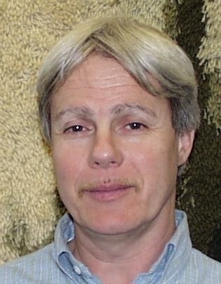
Steven A. Curtis has been the Head of the Planetary Magnetospheres Branch in the Laboratory for Ex-traterrestrial Physics at Goddard Space Flight Center for the past decade. He was a Principle Investigator in NASA’s Space Physics Theory Program (Global Magnetospheric Simulations) and in NASA’s Remote Exploration and Experimentation Program (advanced spacecraft onboard computing). He is presently Project Scientist for the 4-5 spacecraft Magnetospheric Multi Scale in which he has played a leading role in conceptualizing the science and spacecraft design implementation. His research interests include the global and mesoscale structure of the magnetosphere and its simulation, atmosphere-magnetosphere interactions, and wave-particle interactions in Geospace. He is particularly interested in the multiscale closure needed between theory and observations. He received his Ph.D., M.S., and B.S. in Physics from the University of Maryland.

Walt Truszkowski is currently the Senior Technologist in the Advanced Architectures and Automation Branch at NASA's Goddard Space Flight Center. In that capacity he is responsible for managing the agent technology research for the Branch. Currently work is underway to establish an agent-based system for the ESA/NASA satellite SOHO. He also serves as the Lead of the Information Technology Research Group in the Branch. In that capacity, he is leading an effort to create a repository of information on technologies of importance to researchers in the organization. He is also leading the research in the areas of human factors of website design/use and the application of agents for the intelligent access and management of web-based information.
He is a National Research Council (NRC) accredited Fellow participating in the Resident Researcher's Associate (RRA) program at the Goddard Space Flight Center.

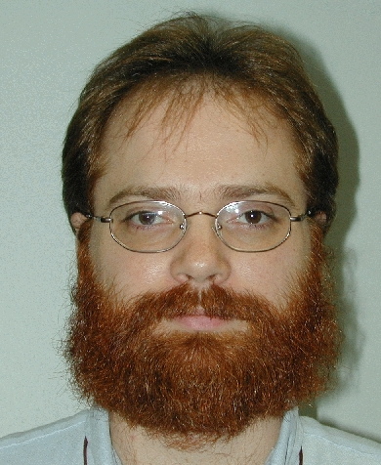
Michael L. Rilee is a scientist with L-3 Communications supporting the GSFC Laboratory for Extraterrestrial Physics and the Science Computing Branch of the GSFC Earth and Space Science Computing Division. For NASA’s Remote Exploration and Experimentation project he has lead development of the Plasma Moment Application and the Radio Astronomical Imager which are science data analysis applications designed for space borne supercomputers. He is currently researching a High Performance Computing System that may fly on Magnetospheric Multi Scale (launch 2007). At GSFC he has been active in Nano-Satellite technology development and the application of parallel computing to data analysis and astrophysical fluid simulation (PARAMESH). He received his Ph.D. and M.S. in Astrophysics (Plasma Physics) from Cornell University, and his B.A. in Astrophysics and Mathematics from the University of Virginia in Charlottesville, VA.

Pamela E. Clark is a scientist with L-3 Communications supporting the GSFC Laboratory for Extraterestrial Physics. She is currently active with the Magnetospheric Multi-Scale mission and plays a central role in the development of the ANTS mission concepts. She has been involved with numerous flight projects including the Near Earth Asteroid Rendezvous, Pioneer Venus, Mars Observer, Magellan, and Mercury Messenger. In her work she has sought to correlate remote sensing measurements with sample and in-situ measurements to better understand the origin and evolution of terrains across the Solar System. She received her Ph.D. from the University of Maryland.

0-7803-7651-X/03/$17.00 © 2003 IEEE
IEEEAC Paper # 1248, Updated 10, December 2002

